SID: 202104114 STUDENT NAME: Anas Madkoor Effort given 33%

SID: 202007437 STUDENT NAME: Abdullah al naemi Effort given 33%

SID: 201803368 STUDENT NAME: Mansoor afeer Effort given 33%

• Course number: CMPS310

• Submission date: December 9th

• Theory Class section: L02

• DECLARATION: We hereby certify that no part of this project or product has been copied from any other student’s work or from any other sources except where due acknowledgment is made in the project. No part of this project/product has been written/produced for us by any other person

**Task 1:**

Selecting an appropriate software development life cycle (SDLC) model for the Conference Management System (CMS) project is crucial for its success. Given the requirements outlined for the CMS, a suitable SDLC model would be the Iterative and Incremental Development (IID) model for the following reasons:

1. Flexibility and Adaptability:

Agile allows for flexibility and adaptability, making it well-suited for projects with evolving requirements and the need for future modifications.

1. Incremental Development:

Agile's incremental development approach aligns with the project's requirement for continuous upgrades and additions of new functionalities.

1. Interoperability and Portability:

Agile allows for continuous testing and integration, ensuring that the system remains interoperable and portable throughout its development.

1. Collaboration and Communication:

Agile encourages collaboration and frequent communication among the development team and stakeholders, which is crucial for managing a project with limited staff.

1. Iterative Improvement:

The iterative nature of Agile enables constant improvement based on feedback, making it suitable for a system that may require upgrading and modifications over time.

1. Efficient Resource Utilization:

Agile promotes efficient resource utilization and prioritizes features based on their value, aligning with the project's constraints on staff and server resources.

1. Security Considerations:

Confidentiality continuous attention to security concerns, ensuring that confidentiality requirements are addressed throughout the development process.

1. High Availability:

The iterative and incremental development in Agile allows for the continuous improvement of system availability, supporting the project's goal of high system availability.

In summary, the Agile SDLC model is well-suited for the CMS project, considering its constraints, non-functional requirements, and the need for flexibility, collaboration, and continuous improvement.

**Task 2:**

**Milestone 1 gnatt chart:**

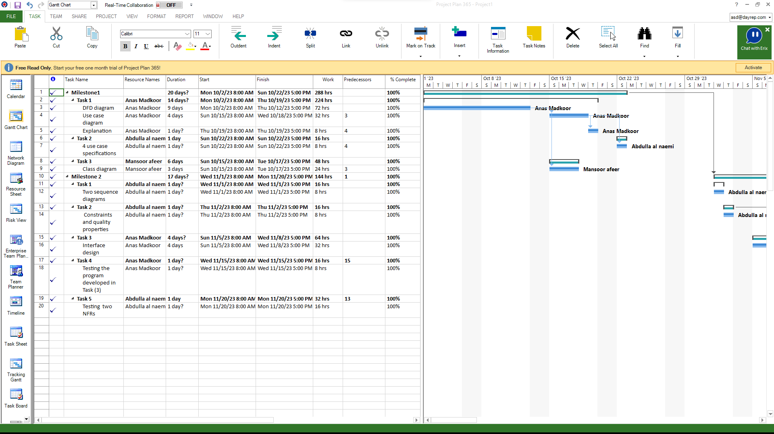

**Milestone 2 gnatt chart:**

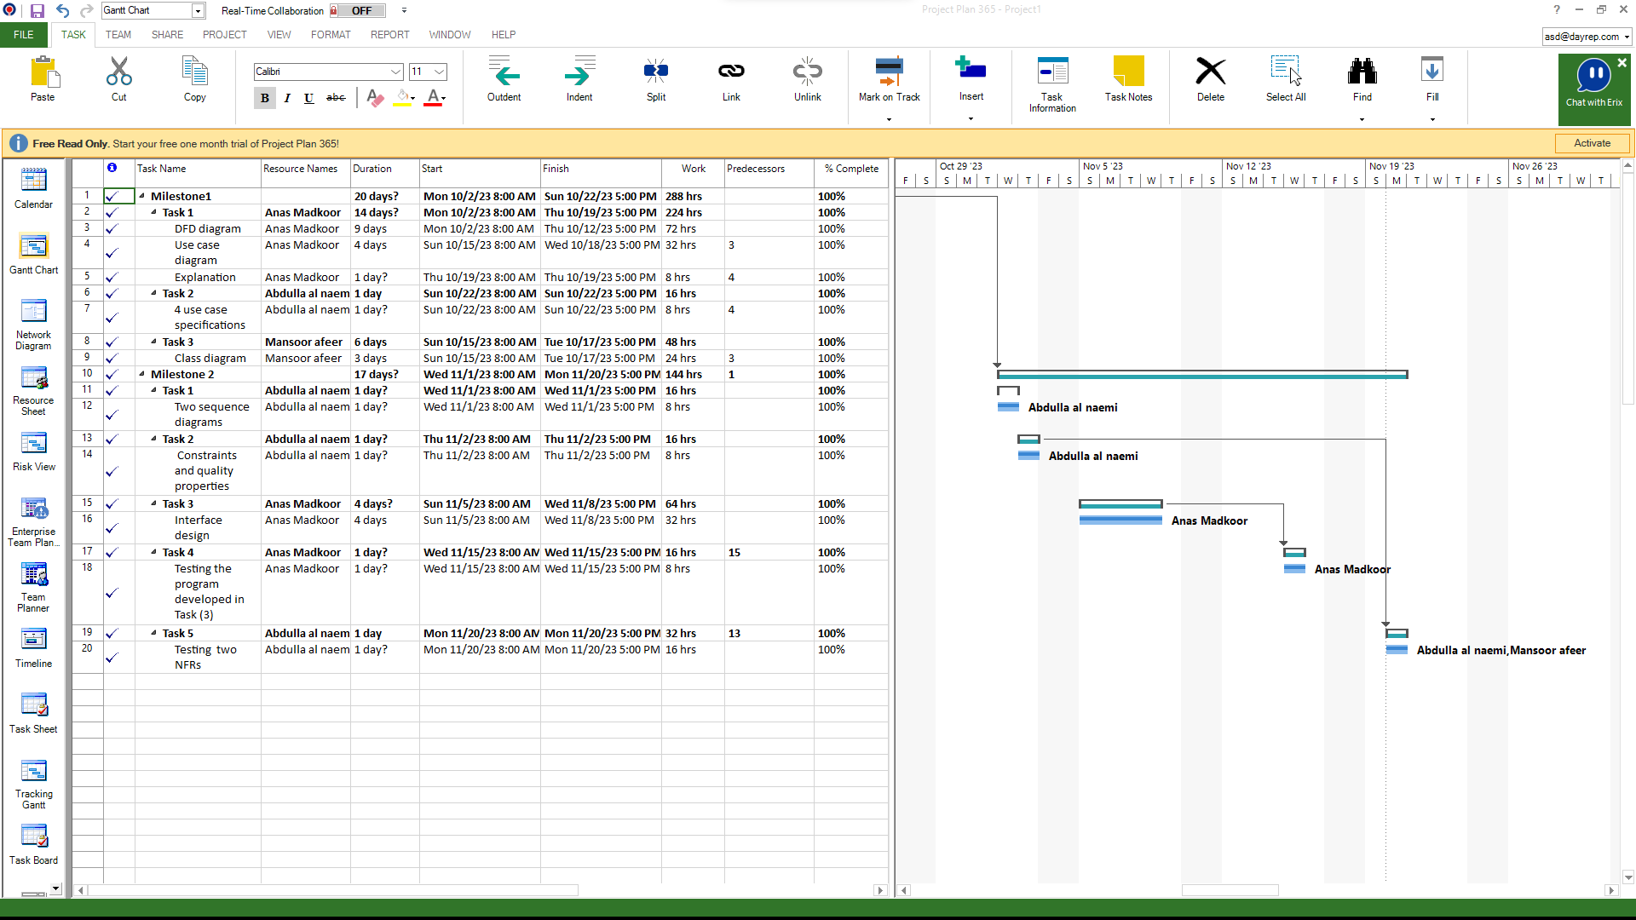

**Dependency graph Milestone 1**

M1

12/10/23

Use case

3 DAYS

DFD

10 DAYS

Start

2/10/23

M2

18/10/23

Explanation

A DAY

Class diagram

3 DAYS

4 Use case specifications

A DAY

M3 (milestone 1 finito)

22/10/23

**Dependency graph Milestone 2**

Two sequence diagrams

A DAY

M3 (milestone 1)

Start

1/11/23

Interface design

4 DAYS

Constraints and NFR

A DAY

M4

2/11/23

M5

8/11/23

Two NFRs test

A DAY

Interface Test

A DAY

End

20/11/23

**Task 3:**

As I reflect on the Conference Management System (CMS) project undertaken during this semester, I find that the experience has been both challenging and enriching. The project, which aimed to develop a comprehensive system for Qatar University, involved a myriad of complexities that tested our skills and teamwork. In this reflection, I would like to share some insights into the journey and highlight key aspects of the project.

Experience:

The CMS project provided a practical application of theoretical knowledge gained throughout the semester. It was an opportunity to dive deep into the complexities of system design, development, and deployment. Working on a real-world scenario allowed for a holistic understanding of the challenges involved in creating a system that meets the diverse needs of organizers, authors, reviewers, and administrators.

Problems Faced:

Like any complex project, we encountered several challenges. Managing constraints such as limited resources, budget, and the need for interoperability and portability required careful planning. Ensuring data confidentiality, especially with authors' account information, added an additional layer of complexity. Balancing these constraints and requirements demanded continuous collaboration and problem-solving within the team.

Something Learned:

One significant takeaway from this project was the importance of adaptability in software development. The iterative and incremental nature of the Agile model proved instrumental in addressing evolving requirements and incorporating feedback. Additionally, the need for robust security measures to protect confidential information underscored the critical role of ethical considerations in software engineering.

Professional and Ethical Issues:

The project highlighted several professional and ethical considerations. Ensuring the confidentiality of authors' account information required a meticulous approach to data security. Adhering to ethical standards in the handling of sensitive information, managing user permissions, and implementing secure practices throughout the development process became paramount.

Team Effectiveness:

The effectiveness of our team played a pivotal role in the success of the project. Regular communication, collaboration, and a shared commitment to quality were the cornerstones of our teamwork. Each team member brought unique strengths to the table, and the collaborative environment fostered a positive and productive atmosphere.

Suggestions for Improvements:

Looking back, there are areas where improvements could be made. Clearer communication channels and more frequent status updates would enhance transparency within the team. Additionally, refining the initial project planning phase to better account for potential challenges could lead to smoother development cycles.

In conclusion, I would like to express my gratitude for your guidance and support throughout the semester. Your expertise and encouragement were invaluable in navigating the complexities of the CMS project. I believe the lessons learned and experiences gained will contribute significantly to my growth as a software engineering professional.